Strava Mobile Phone Sign Up
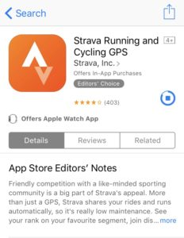
- Search for STRAVA in your app store

- Sign up using your email address

- Once you have signed up go to EXPLORE at the bottom of your device

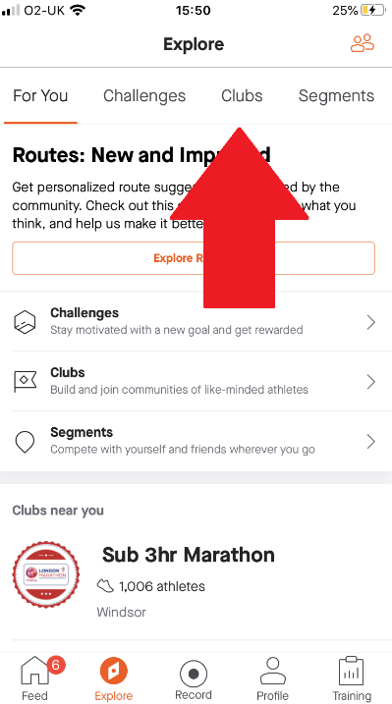
- Click on the CLUBS tab at the top

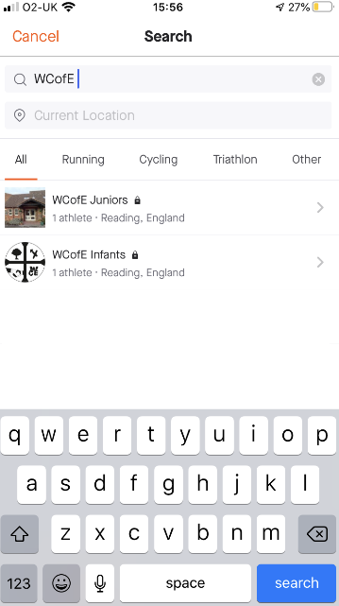
- Search for WCofE Infants or Juniors

- Press on the CLUB you would like to join

- Finally press REQUEST TO JOIN
