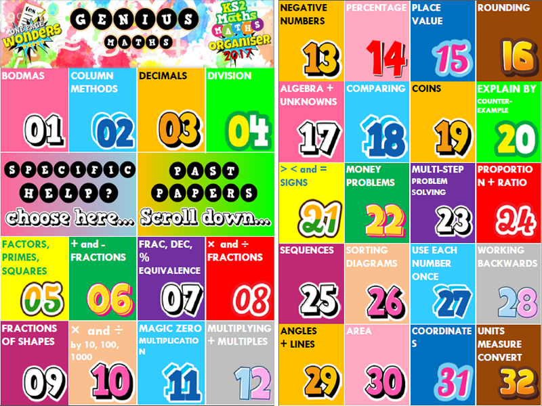
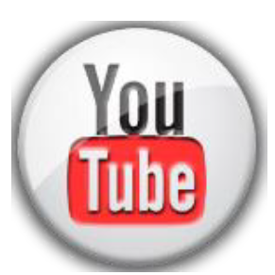
Home Revision Schedule – To match work in school
Y6 Smash Your SATs !
The revision schedule is designed to refresh memories on topics that may have been studies several weeks or months ago and to aid children with their exam technique. The list opposite does not necessarily correspond to what is being covered in class that week. Please watch the videos with your child if possible.
Week Beginning… | Boosters to Focus on at Home
Wk4 – 12th Mar | 19 COINS
Wk7 – Tue 17th Apr | 20 COUNTER EXAMPLES
Wk1 – 19th Feb | 21< and > SIGNS
Wk4 – 12th Mar | 22 MONEY
Wk6 – 26th Mar | 23 PROBLEM SOLVING
Wk4 – 12th Mar | 24 PROPORTION RATIO
Wk4 – 12th Mar | 25 SEQUENCES
Wk7 – Tue 17th Apr | 26 SORTING DIAGRAMS
Wk7 – Tue 17th Apr | 28 WORK BACKWARDS
Wk5 – 19th Mar | 29 ANGLES + LINES
Wk5 – 19th Mar | 30 AREA
Wk5 – 19th Mar | 31 COORDINATES
Wk4 – 12th Mar | 32 UNITS AND MEASURES
Wk5 – 19th Mar | 35 PERIMETER
Wk5 – 19th Mar | 36 QUADRILATERALS
Wk4 – 12th Mar | 37 READING SCALES
Wk4 – 12th Mar | 41 TIME
Wk5 – 19th Mar | 42 TRANSLATE SHAPES
Wk6 – 26th Mar | 44-47 CHARTS + GRAPHS
Wk6 – 26th Mar | 48 THE MEAN
Other Topics
Wk1 – 19th Feb – Roman Numerals
Wk4 – 12th Mar – Mixed numbers (fractions)

Week Beginning… | Boosters to Focus on at Home
Wk4 – 12th Mar | 01 BODMAS
Wk1 – 19th Feb  Wk2 – 26th Feb | 02 COLUMN METHODS
Wk1 – 19th Feb | 03 DECIMALS
Wk3 – 5th Mar | 04 DIVISION
Wk2 – 26th Feb | 05 FACTORS, PRIMES
Wk4 – 12th Mar | 06 + and – FRACTIONS
Wk3 – 5th Mar | 07 FRAC DEC PERCS
Wk4 – 12th Mar | 08 × and ÷ FRACTIONS
Wk4 – 12th Mar | 09 FRACTIONS of SHAPE
Wk2 – 26th Feb | 10 × and ÷ 10, 100, 1000
Wk2 – 26th Feb | 11 MAGIC ZERO
Wk2 – 26th Feb | 12 MULTIPLYING
Wk1 – 19th Feb | 13 NEGATIVE NUMBERS
Wk3 – 5th Mar | 14 PERCENTAGE
Wk1 – 19th Feb | 15 PLACE VALUE
Wk1 – 19th Feb | 16 ROUNDING
Wk7 – Tue 17th Apr | 17 UNKNOWNS
Wk1 – 19th Feb | 18 COMPARING

Find the “Maths KS2 SATs Buster” on the school website. Choose a specific topic to target a weakness or a past paper for mixed revision. All files can be printed out or streamed
HIT the Youtube button if you get stuck and watch the video explanation. Pause, rewind and watch again as many times as you like !

