Dear Parent / Carer,
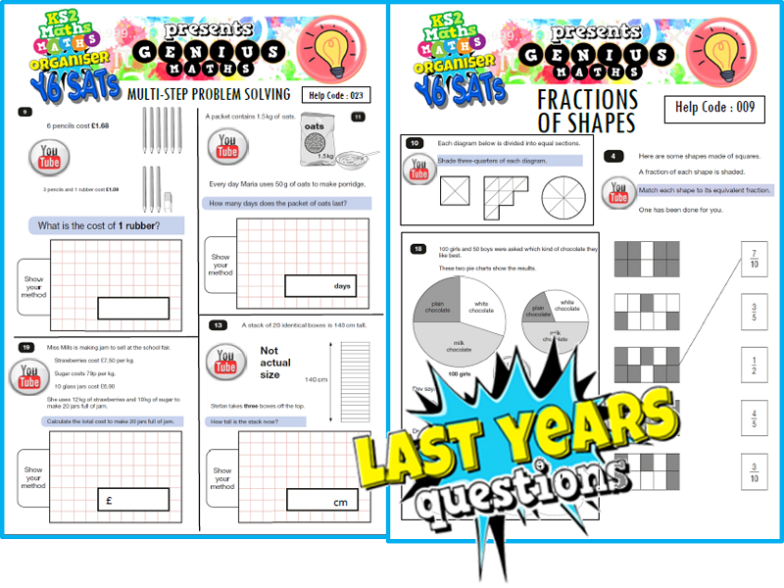
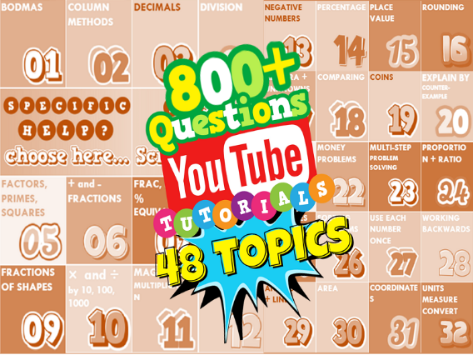
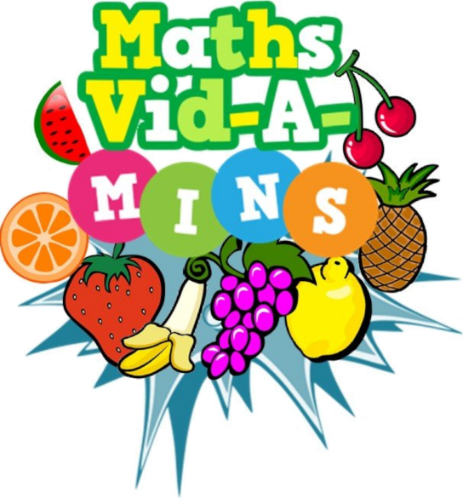
Please find enclosed useful information on how your child can prepare for their KS2 mathematics SATs whether they are in Year 5 or 6, using resources available on the school website at www.woodleyceprimary.co.uk. For Year 6, there are topic boosters and past papers with video tutorials to help target specific weaknesses. For Year 5, there is a mini-maths (less than 5 minute) video for every day of the year to help establish a daily routine and thinking-outside-the-box puzzles. The resources can be used on PCs, laptops, tablets and mobile phones via the website. Students who have used the resources in the last couple of years have said how it has helped them understand and be more successful in their maths.
How to find the resources at www.woodleyceprimary.co.uk
Different mini- maths video for every day of the year. Click the month, and then today’s date. Puzzles too!

Go to the school website on PC, laptop, tablet or phone. Click “Links” on the top tab of the website.

